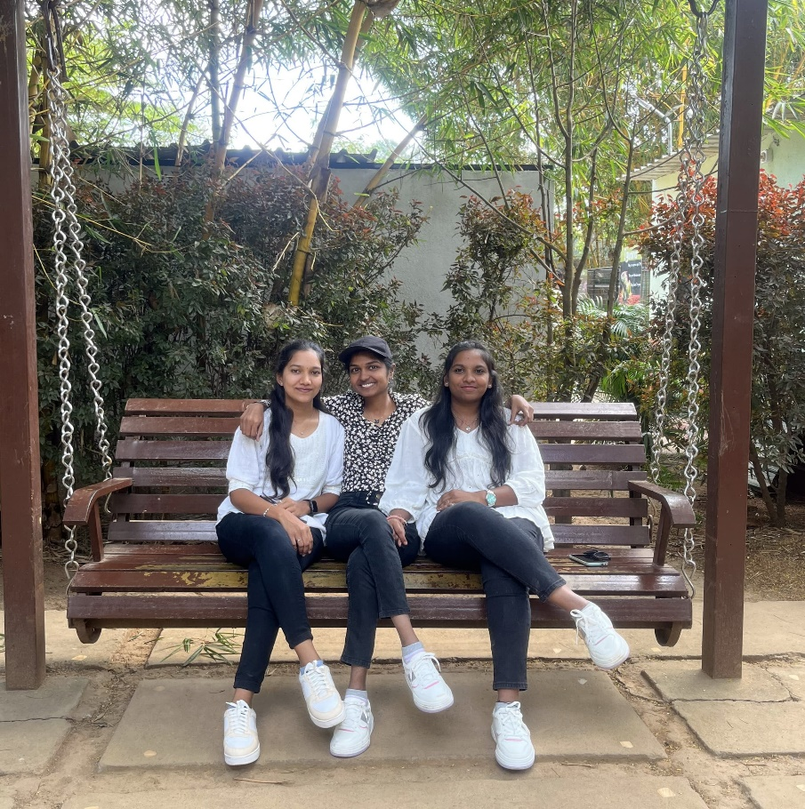

Meet my partners in crime

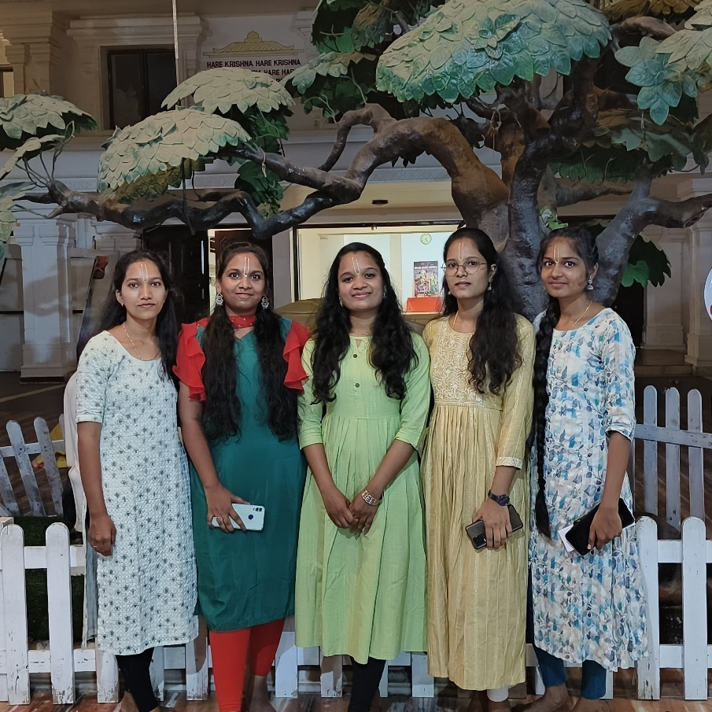

As sweet as honey, strong as a rock

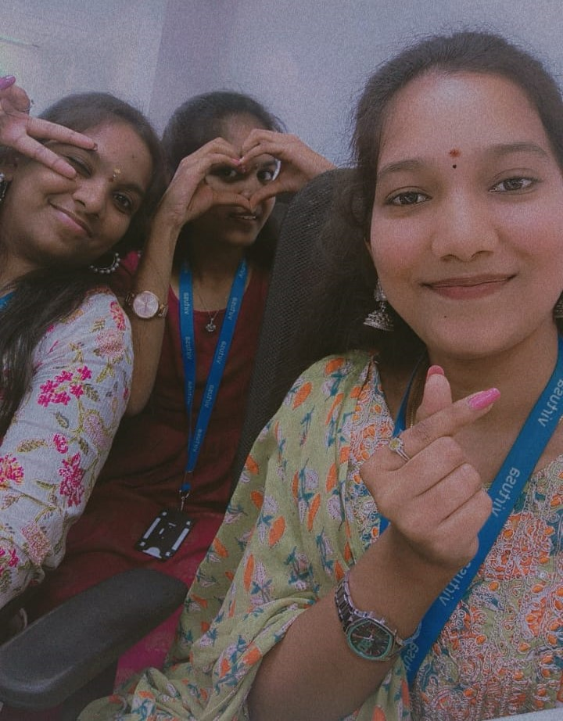

Laughing , loving and living

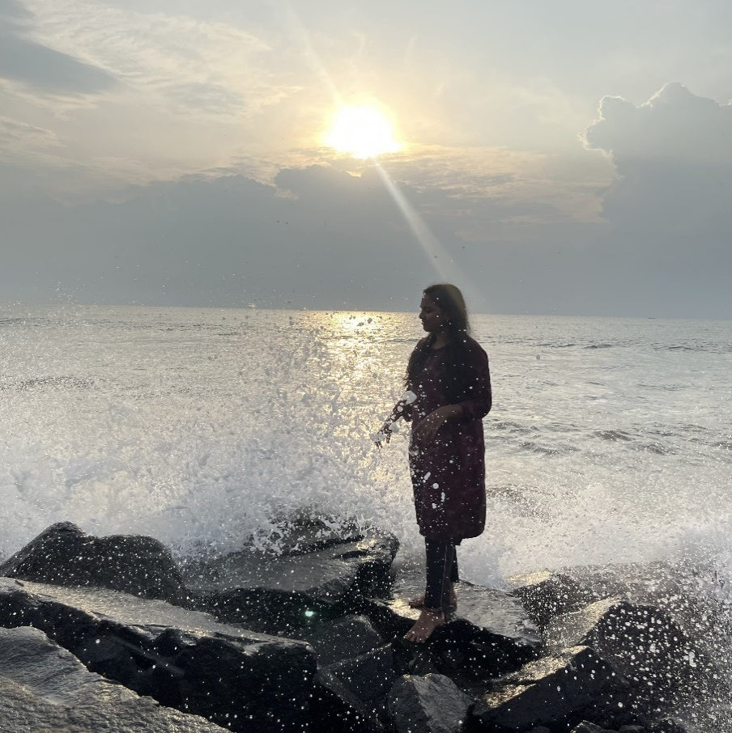

Welcome to my world having full of stuff also with plenty of fun and joy…😊

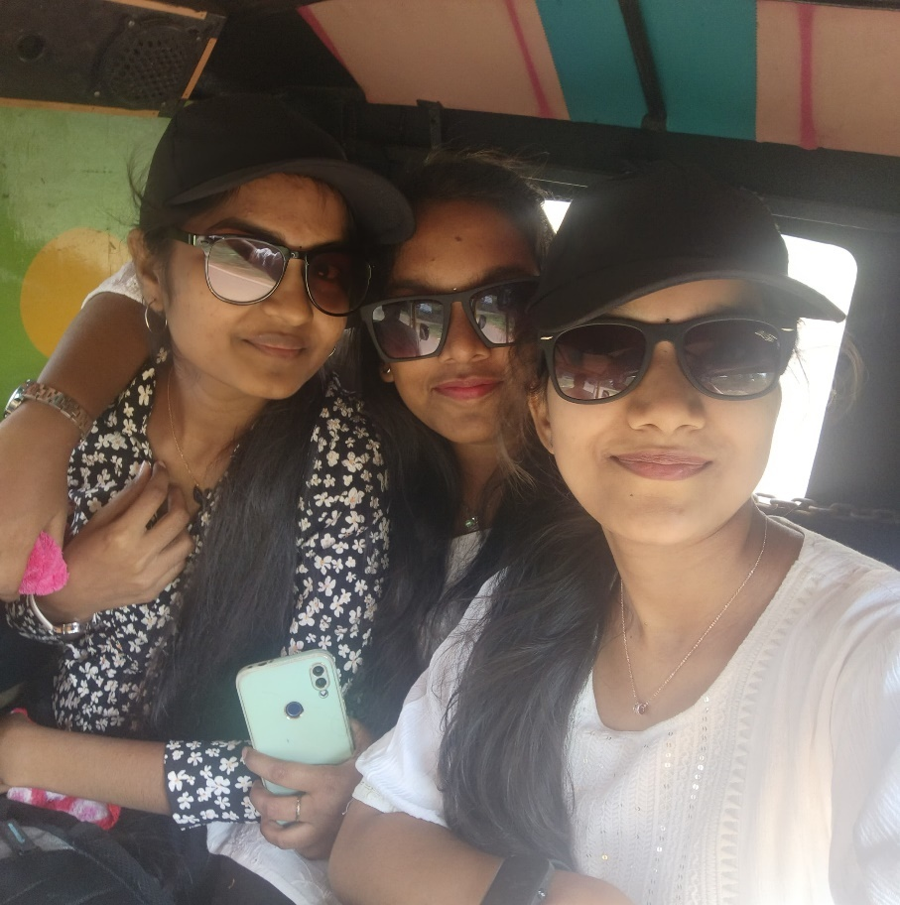

Me creating unforgettable moments with my cuties that will live on forever

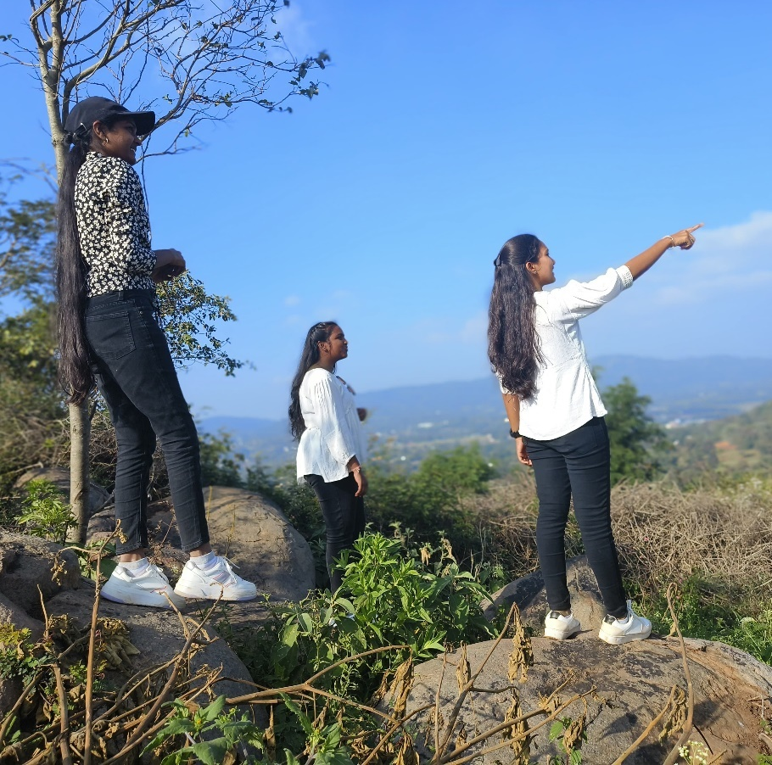

Finding the star(Anuradha nakshatram) before marriage, but I seen nothing right over their

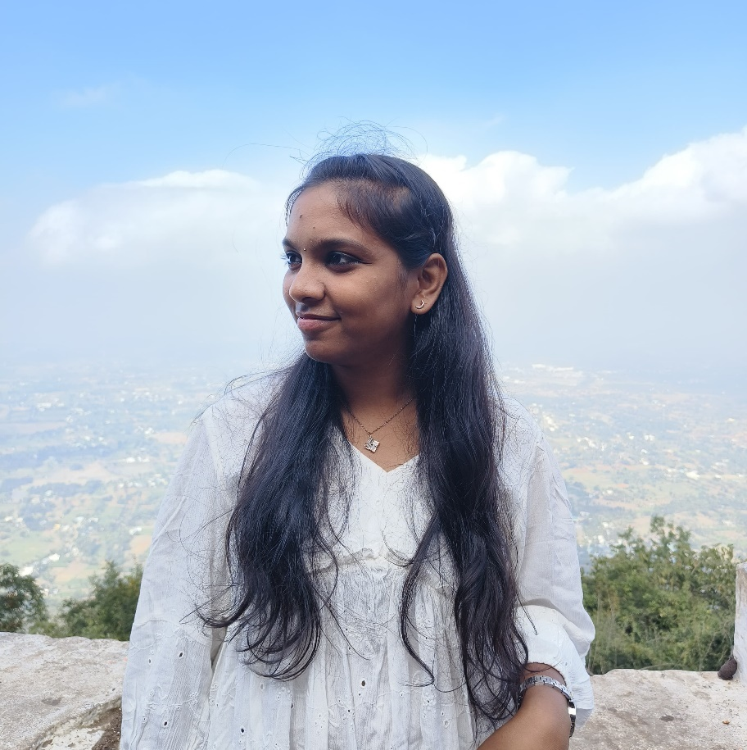

A sight to Behold

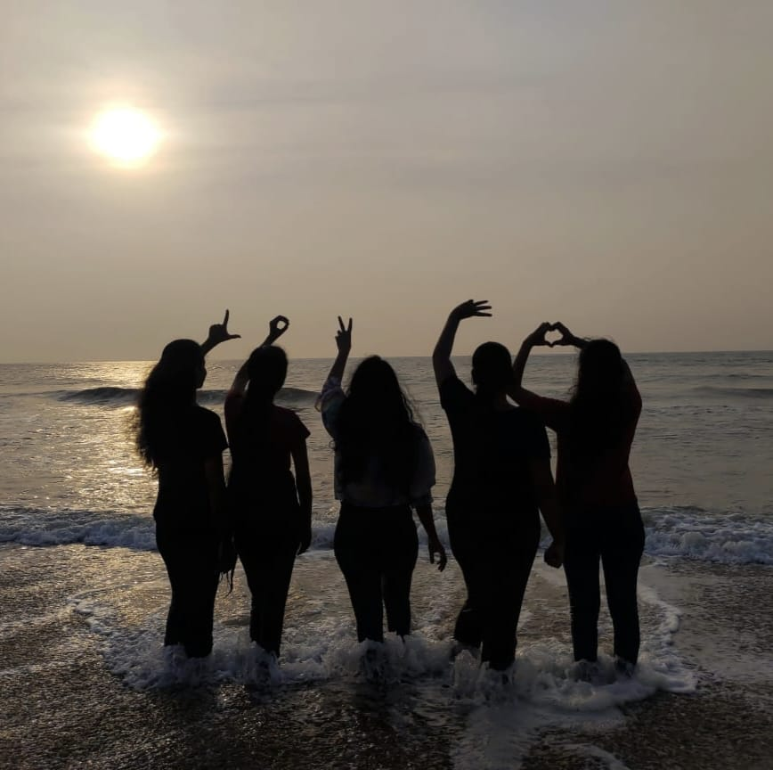

Unfortunately we felled in love with Bay of Bengal

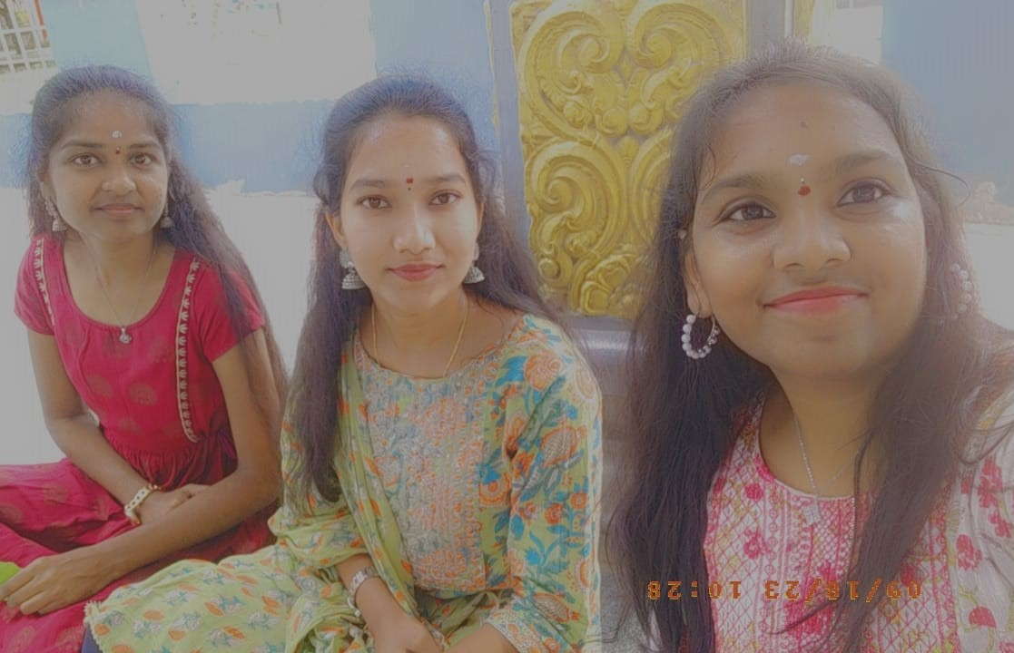

Snap shot with my babies by sitting on the lap of Lord Shiva

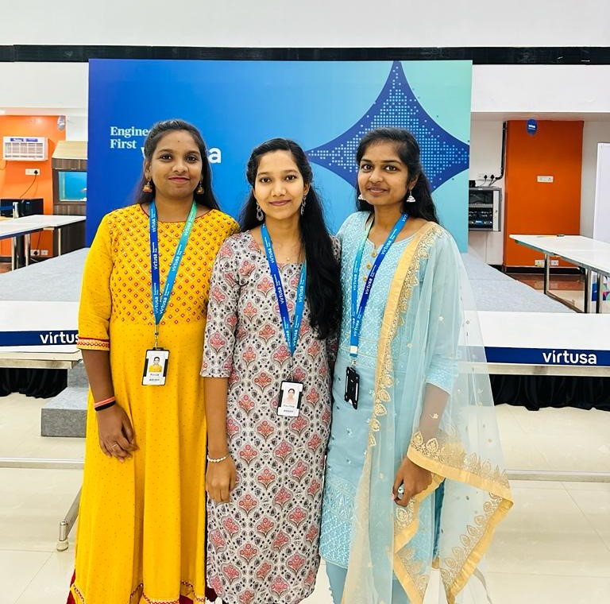

Traditional fashion and looks in my office and everywhere will never goes out of style.

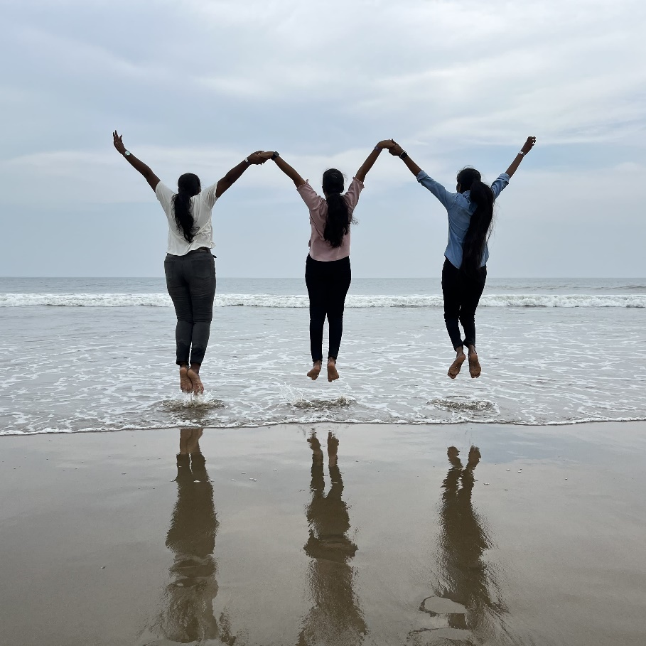

We and the ocean --- Love at first sight…

(Or)

We don’t care for Gravitational force…

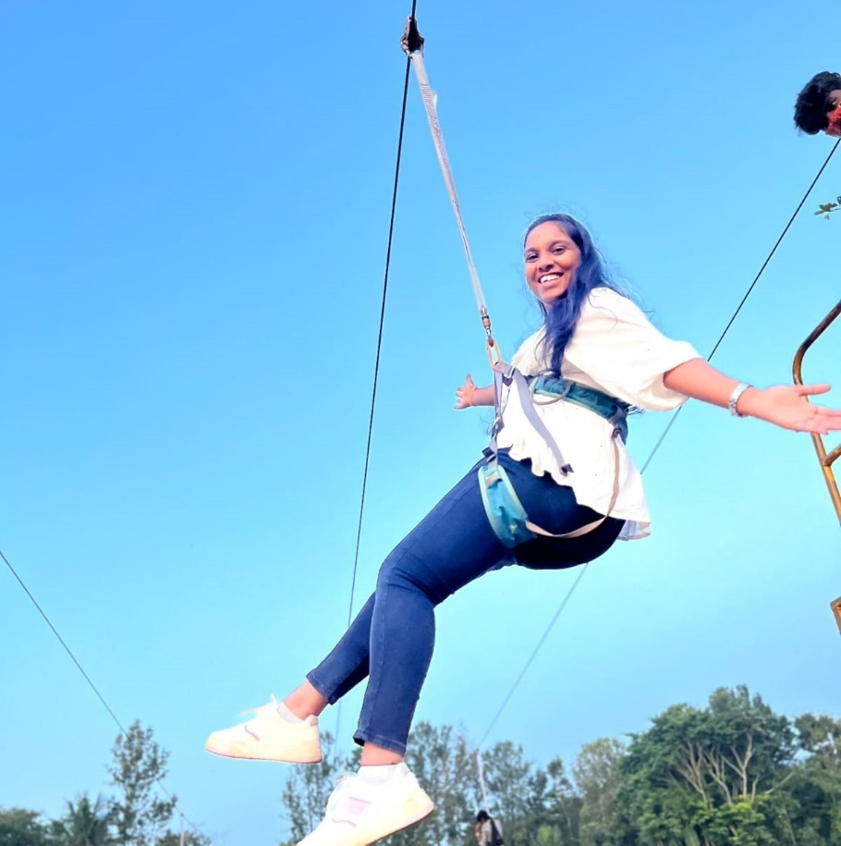

I’m a girl with a greatest adventure

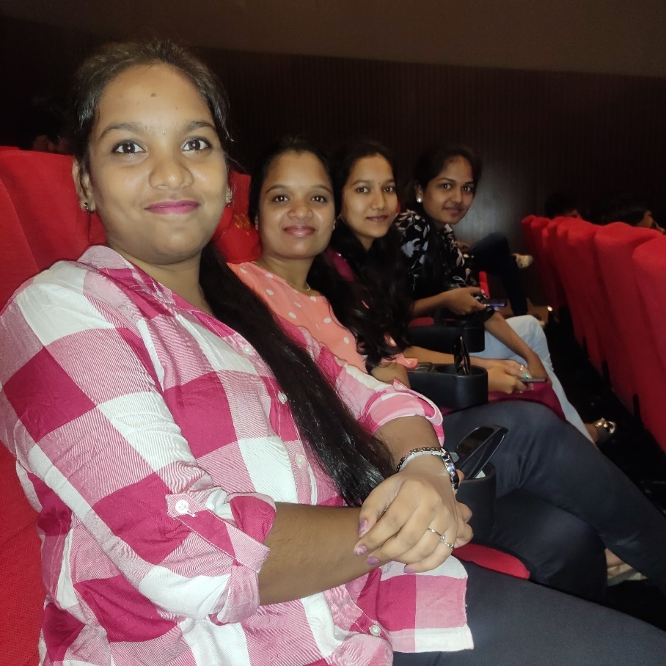

Its show time

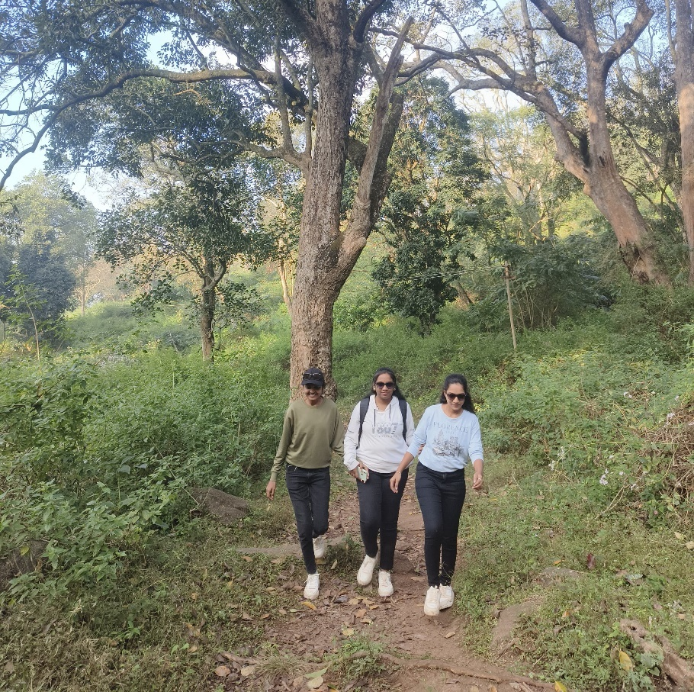

Enter the wild and met the lion…

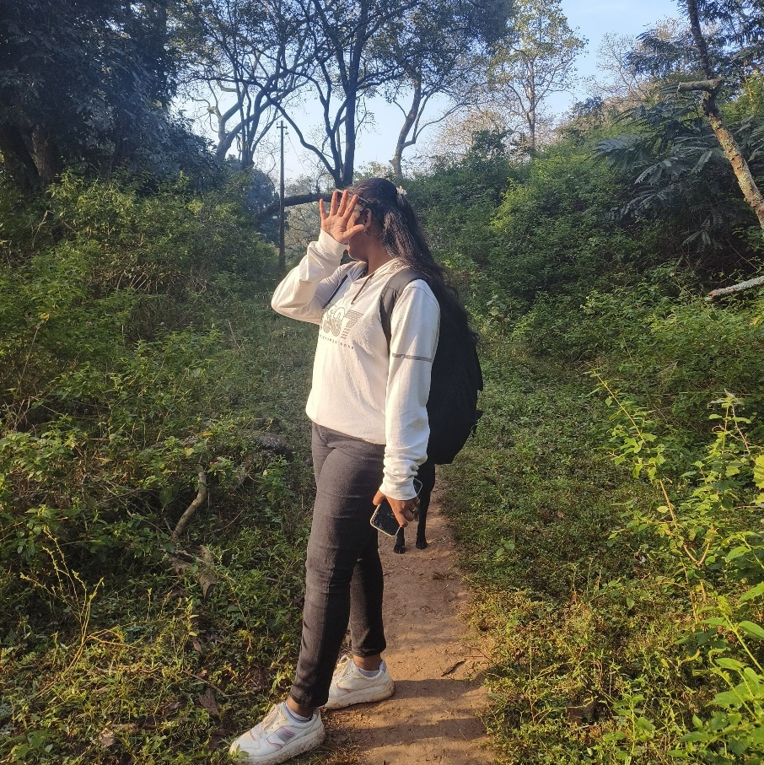

Uffffff Surya bro…some other timee…

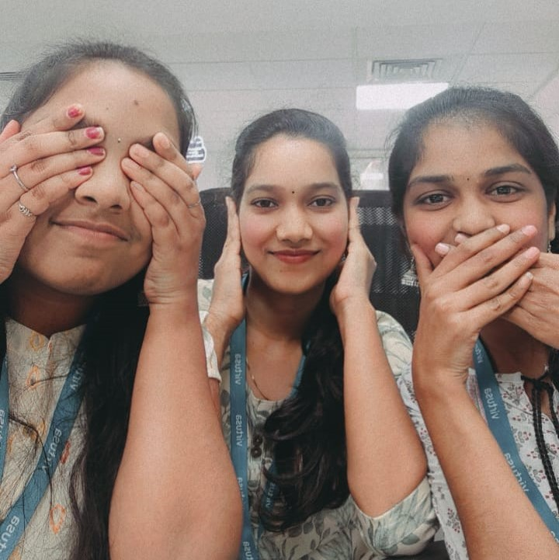

Chedu chudoddu, chedu vinoddu, chedu matladoddu…

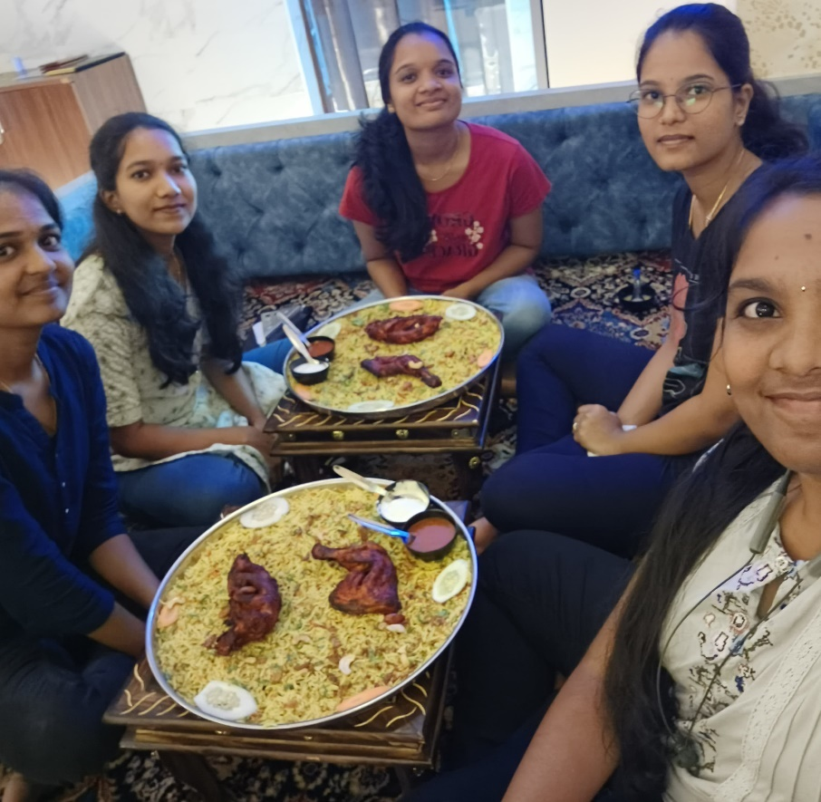

Once upon a time we wasted the costly food…

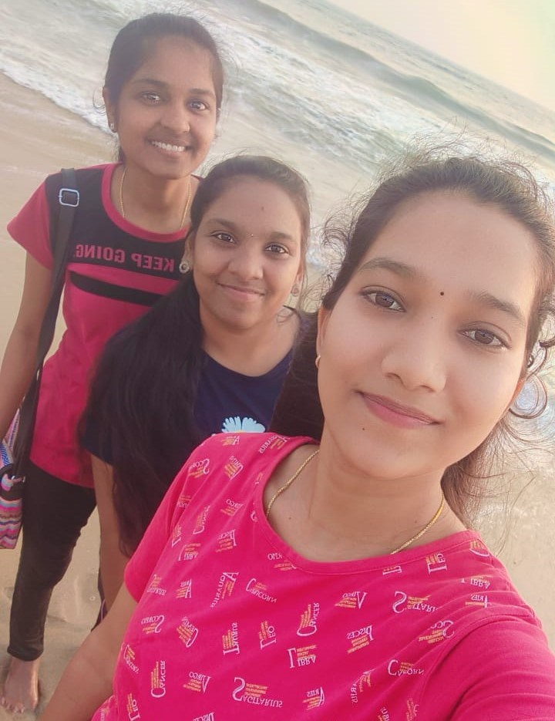

One fine day in paradise

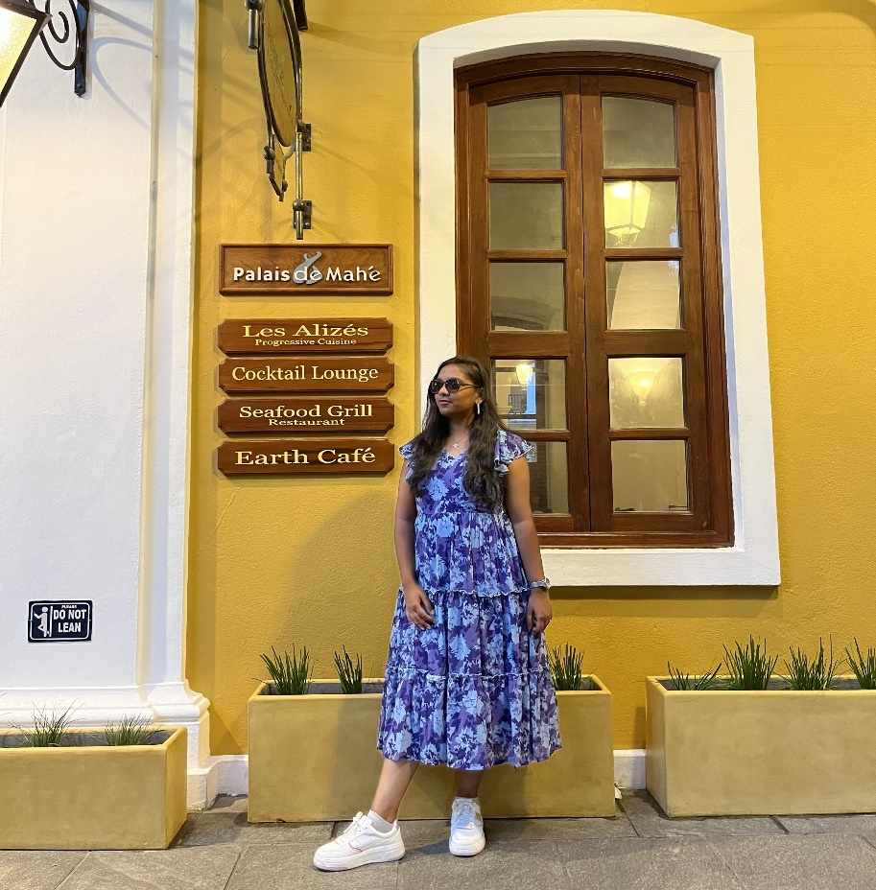

Living with vintage vibes #lamarina #french_coliny

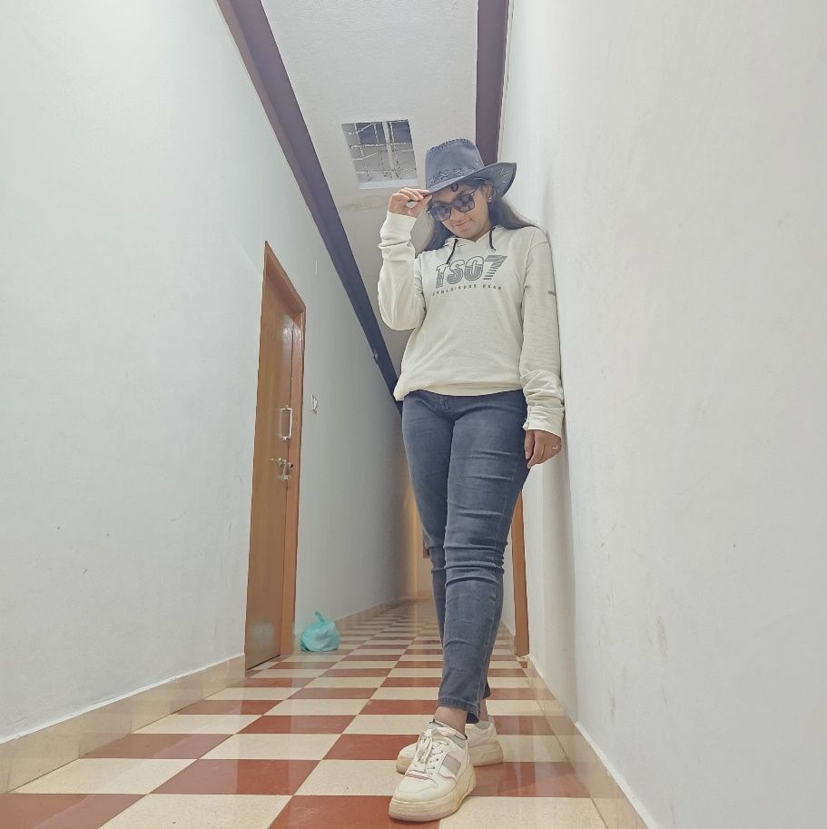

Hold my hat, I’m about show off some cowboy skills

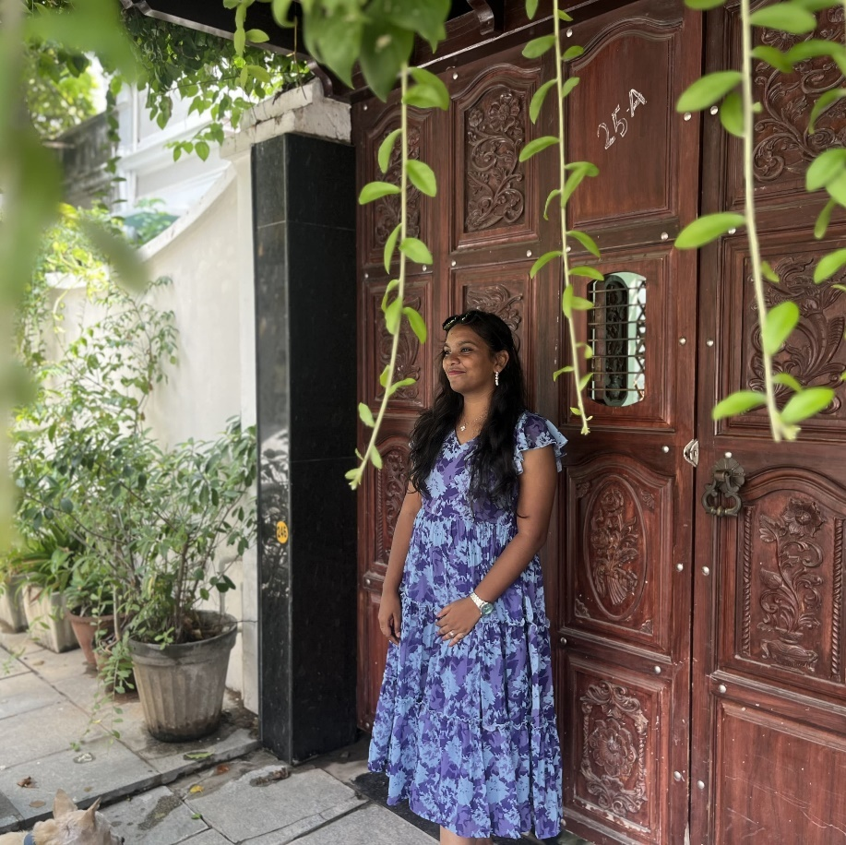

Nothing replace my peaceful smile

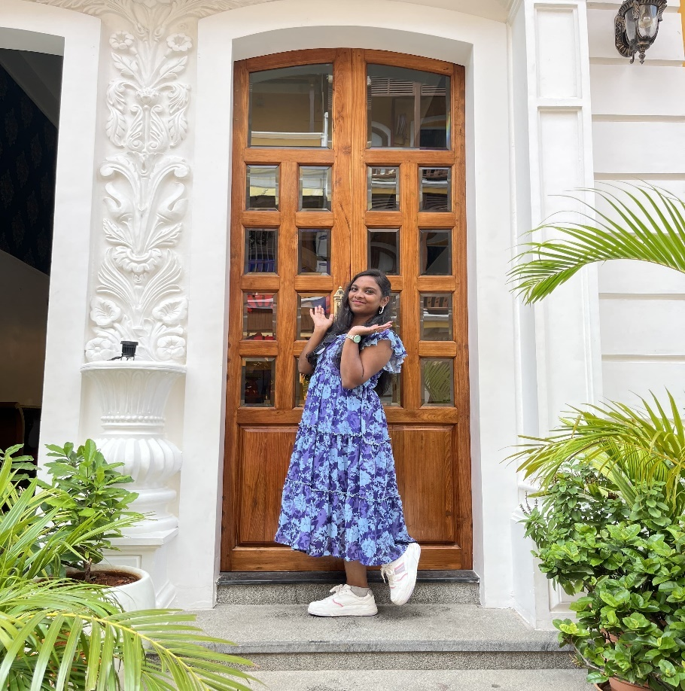

No one can stops me while posing to a camera

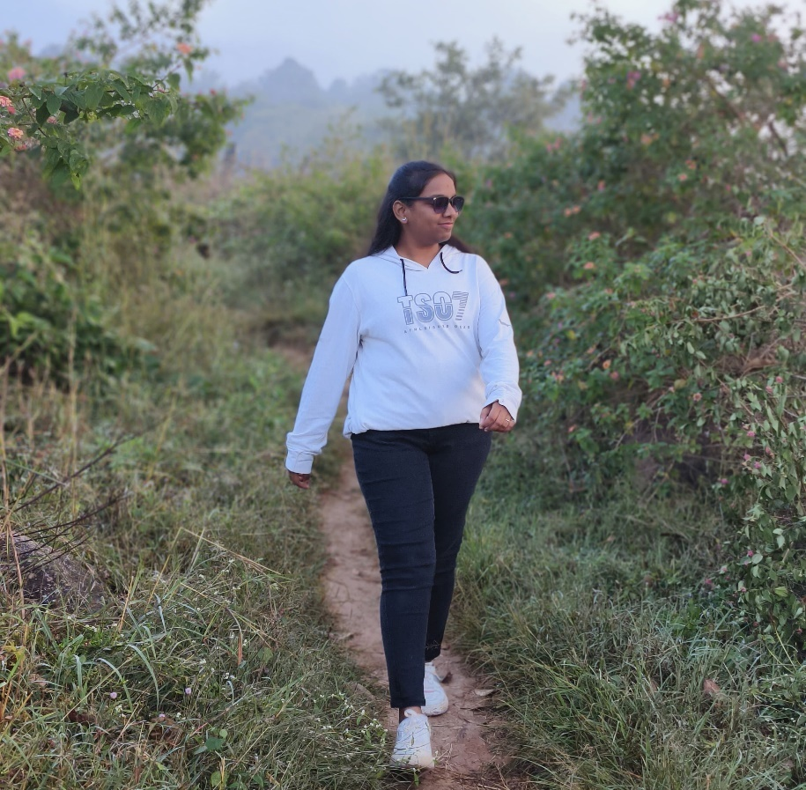

I thought its just a random click, but seen after sometime, this random captured my walk style…

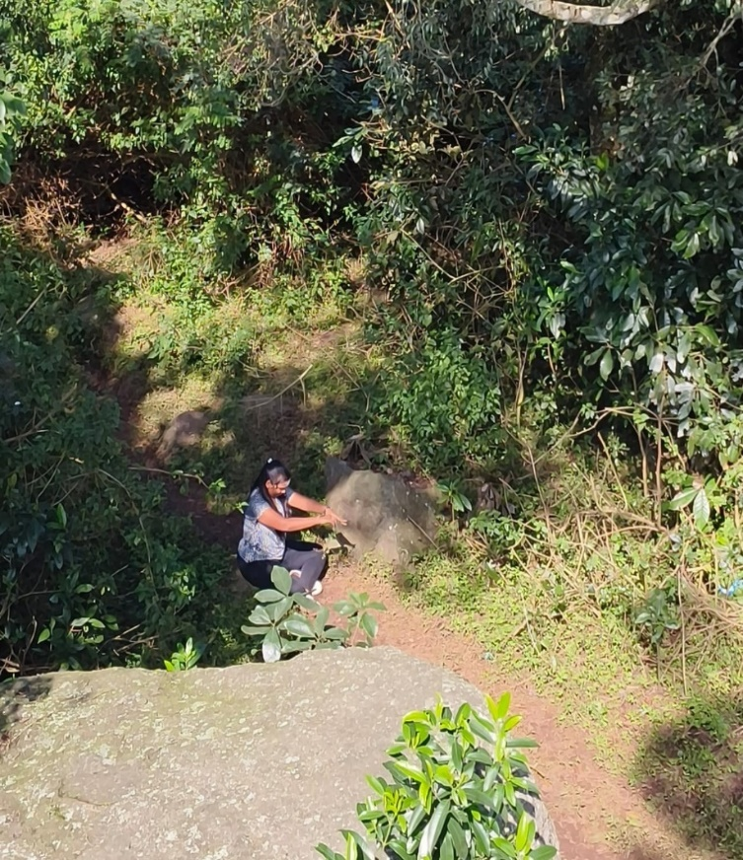

Boopunathu sirasi bhuvapunathu netrayo, swapunathu kante mahapunathu hrudhaye

(Or)

Om kleem kleem iim bhat bhat bhat swahaa…aavahayami….

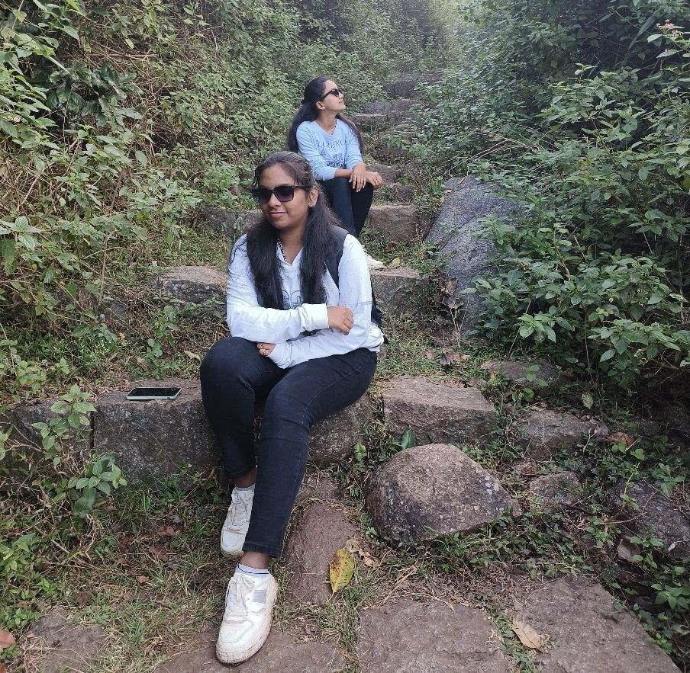

Idooo rakam, Adooo rakam

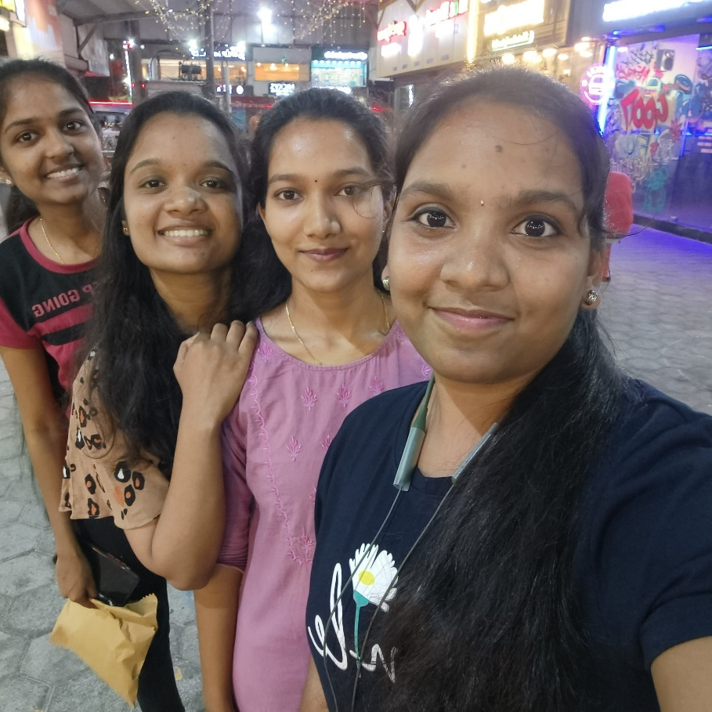

Selfies…selfies…selfies we don’t like, we avoid, but selfies likes us/we, we cant avoid…

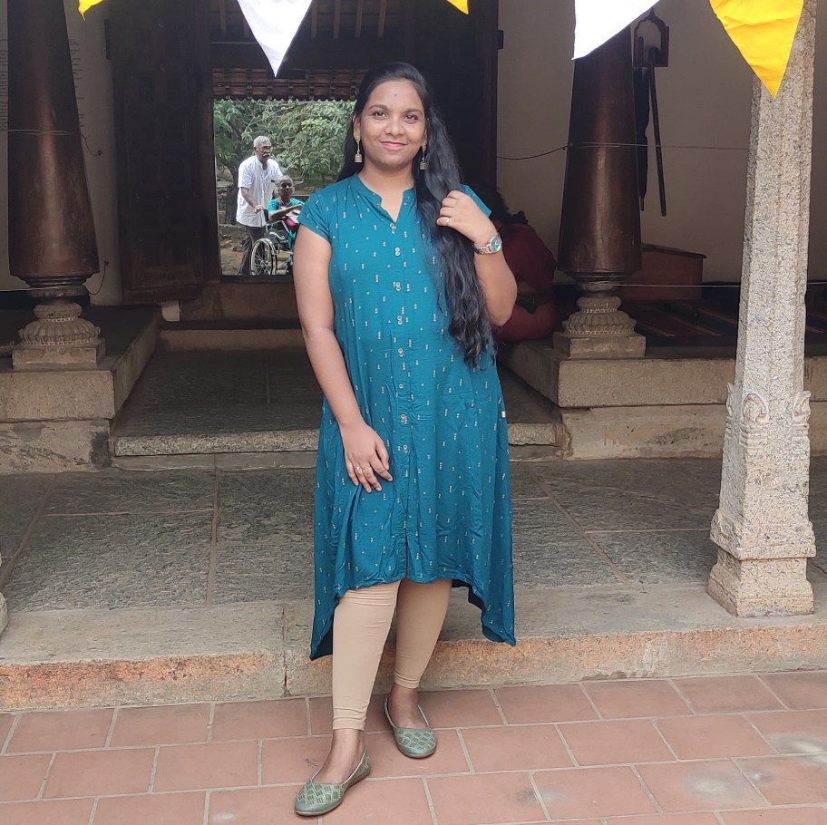

No one can take off my everlasting smile…

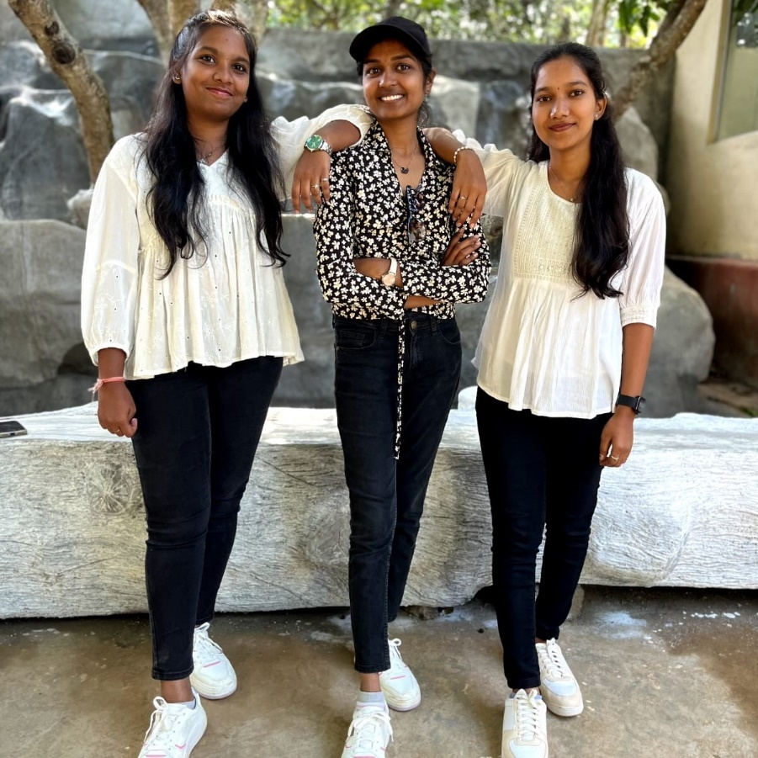

Our bond is stronger than what you seen in background…

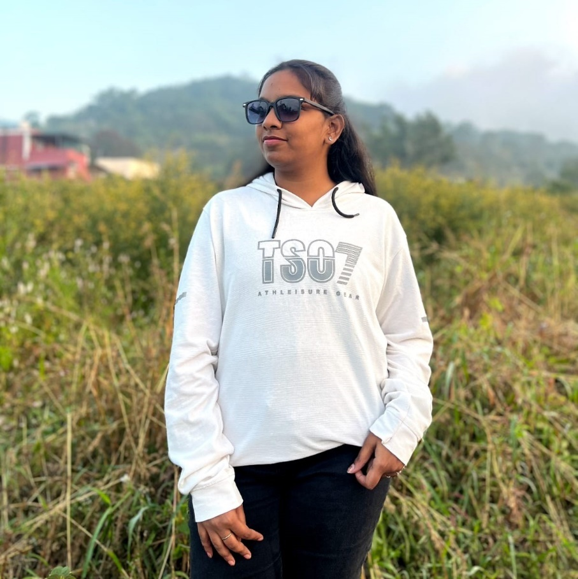

TS07===Thala/Dhoni for a reason

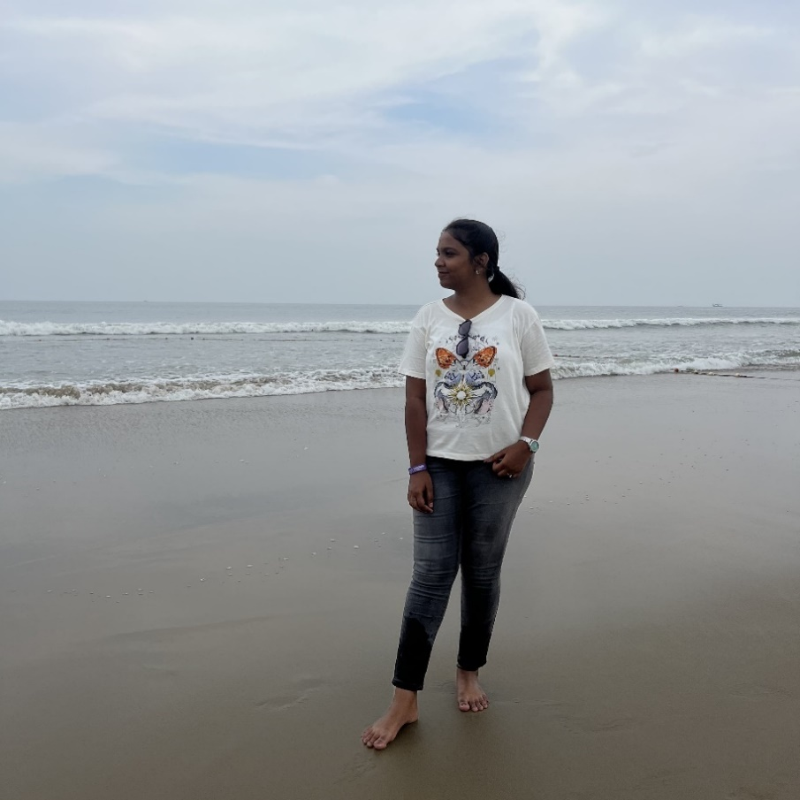

Tanned and Thirsty

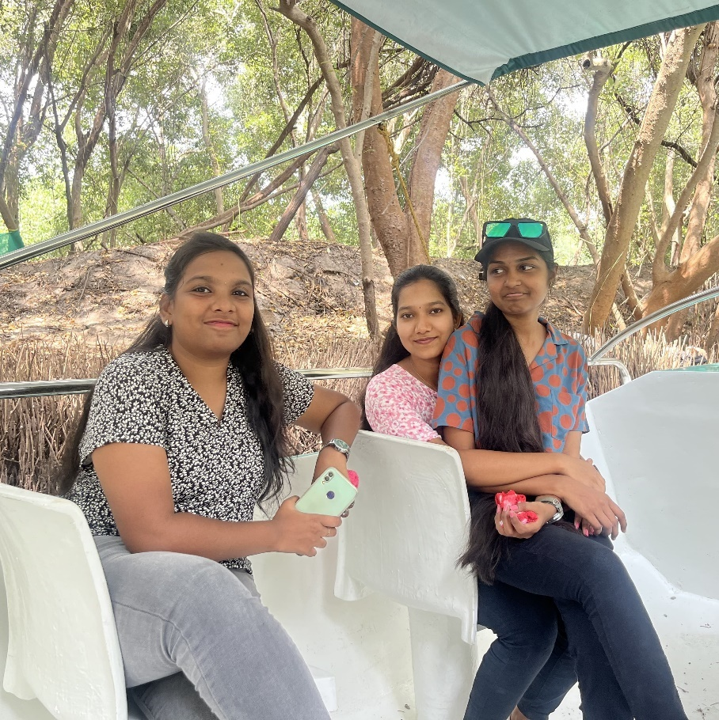

Having fun in forest…

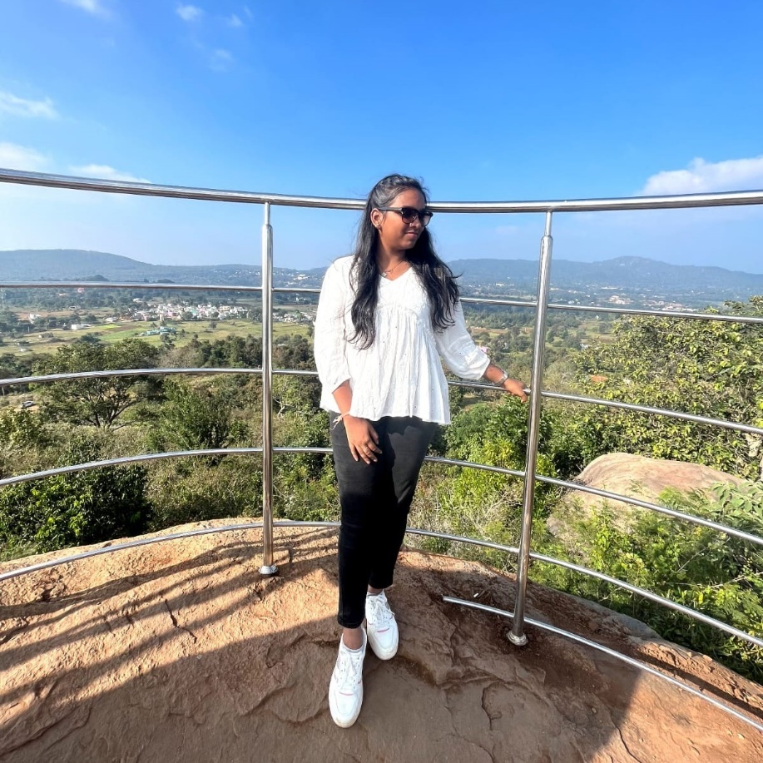

All I need is this breathtaking view…

The end caption : I still haven’t left behind…